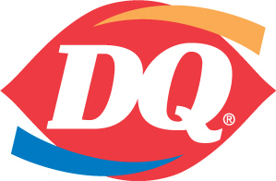
Michigan Dairy Queen Operators Association Membership Form, Year 2019 Annual Dues $50 Per Store
Make check payable to: MDQOA
Mail to: Please Make Note of the New Address
MDQOA
400 Lakeside Drive Waterford, MI 48328
Store # _____________
Owners Name: ________________________________________________
Company Name: ______________________________________________
Address: ___________________________________________________
Street ___________________________________________________
City State Zip
Store Phone # __________________ Home Phone # __________________
Cell Phone # __________________
Email Address ________________________________________________
Mailing Address (If Different From Store)
______________________________________________
Street
______________________________________________
City State Zip
Please fill out all information so we can update our records. If you have more than one store please add additional stores information and numbers to back of this form. Please note: It is $50 per store.
Date Paid: __________________ Check # _____________________

